STATE OF NEVADA
Department of Conservation & Natural Resources
Steve Sisolak, Governor
Jim Lawrence, Acting Director
Colin Robertson, Administrator

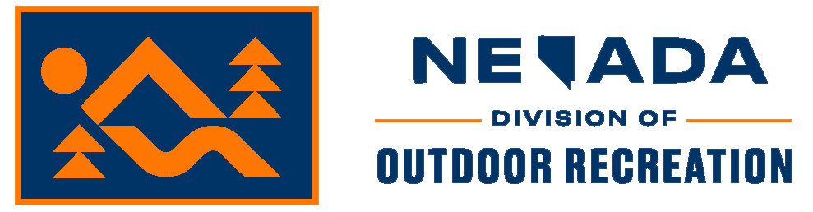
PUBLIC HEARING AGENDA
(REVISED)

THURSDAY, DECEMBER 8, 2022 AT 2:00 P.M. PST
Richard Bryan Building, Tahoe Conference Room 2nd Floor
901 S. Stewart Street, Carson City, NV 89701

Join the Microsoft Teams Meeting:
Microsoft Teams Access Information:
Click here to join the meeting
Meeting ID: 258 019 204 45
Passcode: FaLQCm
Download Teams | Join on the web

Or call in (audio only)
+1 775-321-6111,,213564360# United States, Reno
Phone Conference ID: 213 564 360#
Find a local number | Reset PIN

Note: Items on the agenda may be taken out of the posted order, items may be combined for consideration, and items may be pulled or removed from the agenda.

- Call to Order

- Public Comment
Persons making comment will be asked to begin by stating and spelling their name for the record. All public comments should be as brief and concise as possible so that all who wish to speak may do so (3 minutes for individuals and 5 minutes for group representatives). Comment will not be restricted based on viewpoint.

- Review and Discussion of Proposed Permanent Regulation R088-22
Discussion of regulations pertaining to the implementation of the Nevada Starry Sky Designation Program.

- Adoption of Regulation R088-22 (for possible action)

- Public Comment
Persons making comment will be asked to begin by stating and spelling their name for the record. All public comments should be as brief and concise as possible so that all who wish to speak may do so (3 minutes for individuals and 5 minutes for group representatives). Comment will not be restricted based on viewpoint.

- Adjournment

A copy of all materials relating to the proposed regulations may be obtained at the hearing or by contacting the Nevada Division of Outdoor Recreation, 901 S. Stewart St., Ste. 1003, Carson City, NV 89701, mweintraub@ndor.nv.gov, or (775) 684-2701. In your request, please state that you are requesting materials for the adoption hearing on December 1, 2022. Reasonable efforts will be made for members of the public who have disabilities and require special accommodations for assistance at the meeting. Requests for accommodations or assistance may be submitted to the Department in writing to the address below or by calling 775-684-2701 at least three (3) business days prior to the meeting.

Nevada Division of Outdoor Recreation
Attn: Matthew Weintraub
901 S. Stewart St., Ste. 1003
Carson City, NV 89701
Via email: mweintraub@ndor.nv.gov

Action may not be taken on matters considered during public comment until specifically included on a future agenda as an action item. Notice of this meeting has been sent to all persons on the agency’s mailing list for administrative regulations, posted on the internet through the Division of Outdoor Recreation’s website at http://dcnr.nv.gov/divisions-boards/ndor, and on the Nevada Public Notices website at https://notice.nv.gov/ on or before 9 a.m. thirty days (30) calendar days prior to the meeting. Additionally, notice of this meeting was sent to the Nevada Legislative Counsel Bureau for posting at: https://leg.state.nv.us/App/Notice/A/.

