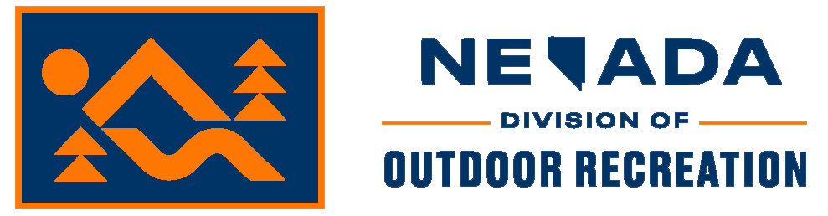 | STATE OF NEVADA  Department of Conservation & Natural Resources  Steve Sisolak, Governor  Bradley Crowell, Director  Colin Robertson, Administrator

NEVADA DIVISION OF OUTDOOR RECREATION SMALL BUSINESS IMPACT STATEMENT

Date: April XX, 2022

RE: Proposed Permanent Changes to Nevada Administrative Code 407A

I, Colin Robertson, Administrator, Nevada Division of Outdoor Recreation, do hereby certify that, to the best of my knowledge or belief:
Pursuant to NRS 233B.060, the proposed administrative regulation changes are not likely to (a) impose a direct or significant economic burden upon a small business, or (b) directly restrict the formation, operation, or expansion of a small business.
The Nevada Division of Outdoor Recreation has determined that the proposed regulations have no significant negative effect on Nevada small businesses. The proposed regulation establishes the process for administering the certification of voluntary dark sky places in Nevada. The purpose of the creation of these regulations is to clarify the process for locations which have voluntarily secured dark sky designation from a third-party entity.
Comment has not been solicited from small businesses, and no summary of their response is provided, because small businesses are not impacted by these regulations and thus a burden or economic impact cannot be assessed.

Respectfully,

Colin Robertson
Administrator, Nevada Division of Outdoor Recreation

