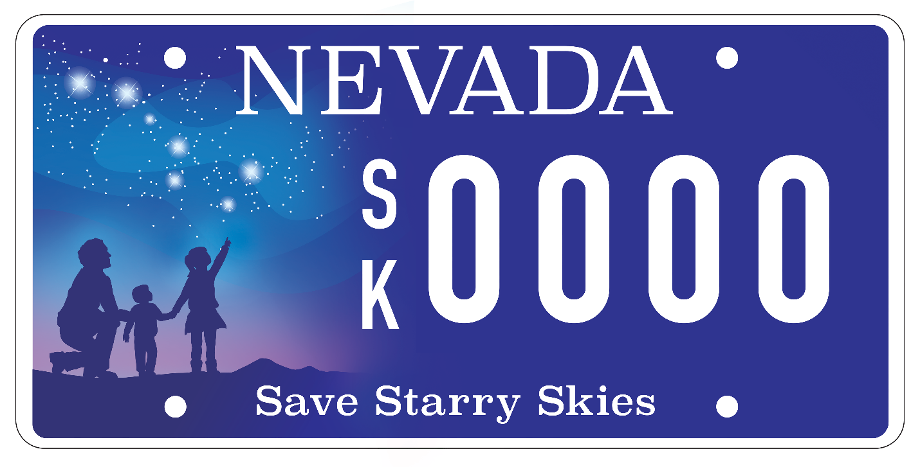
Friends of Nevada Wilderness License Plate. Designed by John Barentine.

