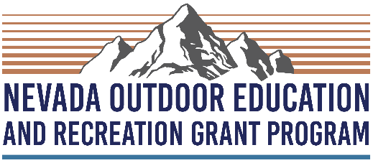 | Grant Application  (Requests greater than $7,500)

Applicant Information
School or Organization Name: |  |  |  |  | Date:
Contact Person:
 |  | Name |  | Title

Address:
 | Street Address | Unit #

 | City | State | ZIP Code

Phone: |  | Email:
Project Name:

Which best describes your organization?

 | Public School |  | Home School |  | Government Agency
 | Private School |  | Non-Profit Organization |  | Tribal Organization
 | Charter School |  | Community-Based Organization |  | Other

Which best describes the project/program type?

 |  | Outdoor Education |  |  |  | Outdoor Recreation |  |  |  | Both Outdoor Education and Recreation
 |  | Outdoor Cultural Programs |  |  |  | Agricultural/ Ranching |  |  |  | Workforce Development
From which Nevada county/counties or tribal lands will students served be from?

How many Nevada students will be directly impacted if selected?
What grade levels will the project serve?
Preschool |  |  |  | Elementary School |  |  | Middle School | High School
Do the students you serve qualify for the following?

 |  |  | Students facing barriers to outdoors |  |  |  |  |  |  |  | If so, what percent? | %
 |  |  | Free/reduced lunch* |  |  |  |  |  |  |  | If so, what percent? | %

*To determine the percentage of students on free and reduced lunch, visit https://agri.nv.gov/Resources/Data_and_Reports/Food_and_Nutrition/SN/SN_Data_Reports/ and use the latest school year data for the school(s) where participants are based. If programming will be based at multiple schools please use data from whichever school will have the highest participation. If programming is community based, please use data from the school nearest the programming site or audience.

Please explain how your audience faces barriers to the outdoors (250 words max):

Organizational Overview
Please tell us about your organization (350 words max)

Proposed Scope of Work
Please provide a brief project description (350 words max)

Program Impacts
Select five program impact areas from the list below that your program implements best. List the impact above each box and describe how this program/project cultivates each impact. Program impact areas:

Connect Students with Nature | Foster Stewardship | Personal Responsibility
Academic Success | Physical Health | Cultural Education
Environmental Literacy | Self Confidence | Community Involvement

a. Program impact (250 words max):

b. Program impact (250 words max):

- Program impact (250 words max):

d. Program impact (250 words max):

e. Program impact (250 words max):

Budget Request

Please submit the program/project budget request using the Nevada Outdoor Education and Recreation budget spreadsheet template.

Disclaimer and Signature
I certify that my answers are true and complete to the best of my knowledge.
If this application is selected for funding, I understand that false or misleading information in my application or presentations may result in the termination of the grant.
Signature: |  | Date:

